**Performance Task for Lab Report**

**NAME : Mir Faris**

**ID : 20-42241-1**

Assume your ID is AB-CDEFG-H. Convert ‘E’, ‘F’ and ‘G’ to 8-bit ASCII characters and together you

have a bit stream of 24 bits.

A = 2

B = 0

C = 4

D = 2

E = 2

F = 4

G = 1

H = 1

Bit stream: 000000100000010000000001

1. 8-ASK: Different amplitudes for 000 to 111 in the modulated signal can be 0 V, 1 V, 2 V, 3 V, 4

V, 5 V, 6 V, and 7 V respectively.

Answer:

f=5;

f2=10;

x = [000 000 100 000 010 000 000 001]; % input signal ;

nx=size(x,2);

i=1;

while i<nx+1

t = i:0.001:i+1;

if x(i)==1

ask=sin(2*pi*f*t);

elseif x(i)==010

ask=2*sin(2*pi*f*t);

elseif x(i)==011

ask=3*sin(2*pi*f*t);

elseif x(i)==100

ask=4*sin(2*pi*f*t);

elseif x(i)==101

ask=5*sin(2*pi*f*t);

elseif x(i)==110

ask=6*sin(2*pi*f*t);

elseif x(i)==111

ask=7*sin(2*pi*f*t);

else

ask=0;

end

subplot(1,1,1);

plot(t,ask);

hold on;

grid on;

axis([1 10 -10 10]);

title('Amplitude Shift Key ID_20-42241-1 SL_20')

i=i+1;

end

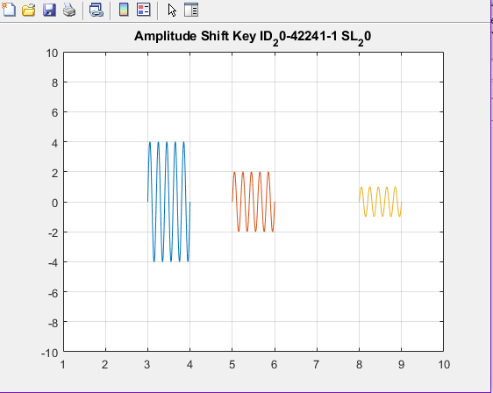

2. 8-FSK: Different frequencies for 000 to 111 in the modulated signal can be 1 Hz, 2 Hz, 3 Hz, 4 Hz, 5 Hz, 6 Hz, 7 Hz, and 8 Hz respectively.

Answer:

f=5;

f2=10;

x = [000 000 100 000 010 000 000 001]; % input signal ;

nx=size(x,2);

i=1;

while i<nx+1

t = i:0.001:i+1;

if x(i)==1

fsk=sin(2*pi*2*f*t);

elseif x(i)==010

fsk=sin(2*pi*3*f*t);

elseif x(i)==011

fsk=sin(2*pi*4*f*t);

elseif x(i)==100

fsk=sin(2*pi*5*f*t);

elseif x(i)==101

fsk=sin(2*pi*6*f*t);

elseif x(i)==110

fsk=6*sin(2*pi*7*f*t);

elseif x(i)==111

fsk=sin(2*pi*8*f*t);

else

fsk=sin(2*pi*f2*t);

end

subplot(1,1,1);

plot(t,fsk);

hold on;

grid on;

axis([1 10 -1 1]);

title('Frequency Shift Key ID_20-42241-1 SL_20')

i=i+1;

end

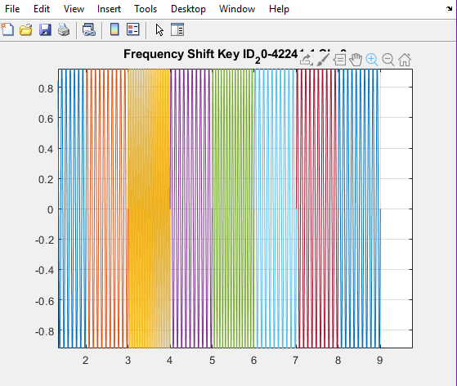

3. 8-PSK: Different phases for 000 to 111 in the modulated signal can be 0, pi/4, 3*pi/4, pi/2, -pi/4, pi/2, pi, -3*pi/4 respectively.

Answer:

f=5;

f2=10;

x = [000 000 100 000 010 000 000 001]; % input signal ;

nx=size(x,2);

i=1;

while i<nx+1

t = i:0.001:i+1;

if x(i)==1

psk=sin(2*pi*f*t);

elseif x(i)==010

psk=sin(2*pi*f*t+pi/4);

elseif x(i)==011

psk=sin(2*pi*f*t+3*pi/4);

elseif x(i)==100

psk=sin(2*pi*f*t+pi/2);

elseif x(i)==101

psk=sin(2*pi*6*f*t-pi/4);

elseif x(i)==110

psk=6*sin(2*pi*f*t-pi/2);

elseif x(i)==111

psk=sin(2*pi*f*t+pi);

else

psk=sin(2*pi*f*t-3*pi/4);

end

subplot(1,1,1);

plot(t,psk);

hold on;

grid on;

axis([0 10 -1 1]);

title('Phase Shift Key ID_20-42241-1 SL_20')

i=i+1;

end

